Lots of Marbles – A Probability Investigation
I have a bag of marbles. The bag contains only red and blue marbles. I draw two marbles from the bag, one after the other. Is it more likely that the marbles are different colours or the same colour?
This probably feels like a question that you cannot answer, but probability can play tricks with our intuition. There is actually quite a lot you can say about this particular scenario!
To make sure that you understand the question, let us imagine that we know exactly how many of each type of marble are in the bag and work out the probabilities. Let us say we have eight red marbles and fourteen blue marbles.
A good way to calculate probabilities in this case is to draw a tree diagram.
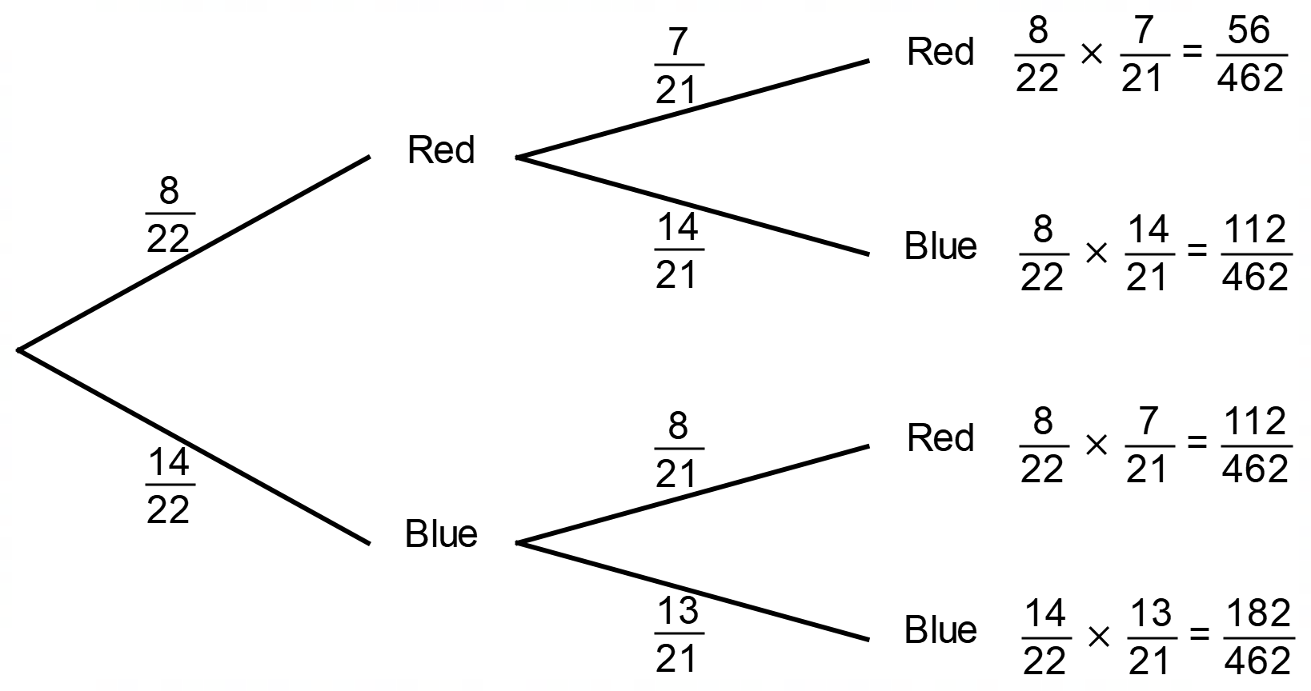
Using this tree diagram, we can show that the probability that the two marbles are the same colour is equal to:
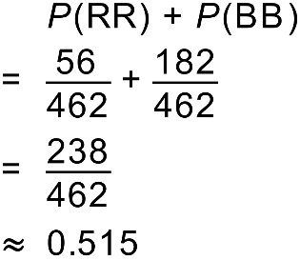
In this scenario, it appears that it is slightly more likely that the two selected marbles will be the same colour.
- Make sure that you understand how the tree diagram above has been calculated and how we have found the final probability. You will need to repeat this calculation many times to understand the problem.
- Show that if you have twelve red and fifteen blue marbles in the bag, the probability that the two selected marbles are the same colour is approximately 0.487.
Once you have completed this exercise, you will be ready to investigate what is happening in more detail!
- Work with a friend, or a small group, to determine the probability that the two marbles will be the same colour for as many scenarios as possible. You might like to collect your results in a table like this one.
 |  | Red
 |  | 2 | 3 | 4 | 5 | 6 | 7 | 8 | 9 | 10 | 11 | 12 | 13 | 14 | 15 | 16 | 17 | 18 | 19 | 20
Blue | 2
 | 3
 | 4
 | 5
 | 6
 | 7
 | 8
 | 9
 | 10
 | 11
 | 12
 | 13
 | 14
 | 15
 | 16
 | 17
 | 18
 | 19
 | 20

- Are there any patterns you can use to fill in the table with less work?
- Are there any tools you can use to help you build the table?
Use the information you have collected to decide whether it is more likely to draw two marbles of the same colour or different colours. Make sure that write down any assumptions you have made.
- If I tell you that there are between 2 and 100 red marbles and between 2 and 100 blue marbles in the bag, is it more likely to draw two matching marbles or two different marbles?
Extension Questions
- If each of the combinations in question 6 are equally likely to occur, what is the probability that you will have two matching marbles?

Exactly 50:50
In your table, you should have noticed that there were a few times when the probability of getting two matching marbles was exactly 0.5. One of these was when you have 6 red marbles and 10 blue. We are going to investigate these cases.
- Given that I have 10 blue marbles, there is another number of red marbles that produces a probability of exactly 0.5. Find the second number of red marbles.
The numbers of red and blue marbles that produce probabilities of exactly 50% follow a specific pattern.
- If you have 66 red marbles, there are two numbers of blue marbles which produce probabilities of exactly 50%. Use any suitable technique to determine the two numbers of blue marbles.

- Describe the pattern in the numbers of marbles that produce probabilities of exactly 50%

Solutions
Most answers to the questions asked can be seen in this Excel Spreadsheet (double click to view in Excel).
4. The table is symmetrical. The entry for 4 red and 5 blue is the same as for 5 red and 4 blue.
5. The use of a spreadsheet is recommended.
6. In the spreadsheet above, you can clearly see that there are far more possibilities where it is more likely to draw two matching marbles.
7. The average of all entries in the above spreadsheet is 0.598. This is the expected value for the probability.
8. 15 red marbles.
9. If you have 66 red marbles, you can have 55 or 78 blue marbles and have an exactly 50% chance of drawing matching marbles.
10. The number of red and blue marbles must be consecutive triangular numbers.

